Issue 1 Friday afternoon

Bozo Bus Tribune

T h e O f f i c i a l O r g a n o f M i n i c o n 5 6
“ W e ' r e a l l b o z o s o n t h i s b u s ! ”

Sing your heart out for Ben Lessinger
The Ephemeral Party, living up to its name, has been canceled. In its place is a last-minute entry (formerly scheduled for function space) about which the pocket program declares only “It's a karaoke party!” So here's a little more information. The Ben Lessinger Karaoke Party, in Room 326, is a Saturday-only memorial party (perhaps the first of several) honoring Ben Lessinger, beloved member of the fannish community who died of natural causes shortly before Minicon last year. Ben was known for running the Karaoke Joe's Café party. This event is brought to us by the Lessinger family and Barb Jensen, with Domenic Brack on equipment.
They could use help of all kinds, whether it's a food or drink donation or technical assistance, since none of your hosts have used the equipment before! Tentative start time will be 7p.m.
And don't forget to tour the rest of Minicon's party line-up Friday and Saturday nights, all located on the 3rd floor hallway opening onto the Atrium. The pocket program has details!

So what's where?
Most things are where they were last year! This year, we welcome back the film room, Cinema Obscura, in Terrace 4. The Spring Room is now splitting its time as a kids' room by day and a home to the music circle by night. The Summer Room (featuring lots of games, two HEPA filters, and tables that are mostly the right size) is our primary gaming space, but gaming is a volatile phenomenon that can erupt in the Lower or Upper Atriums at any time.
(Notes: According to our hotel liaison, the hotel's Easter Brunch will NOT overflow into the Lower Atrium this year. Moreover, do not be dissuaded by the Reserved signs outside the Upper Atrium. It is reserved for us.)
A Stairwell Map of the Doubletree
Want to know which stairs will take you where? Con chair Matt Strait has you covered. Check out this map, which depicts the second floor but also, simultaneously in a spacey-wacey way, every other floor.
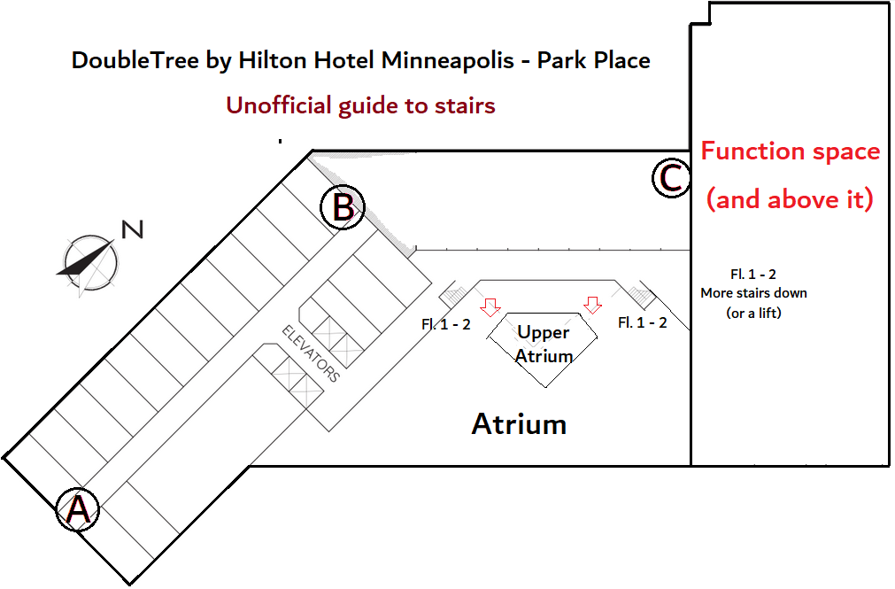
Stairwell key
Stairs A: Emergency exit. Floors 2–5 currently closed for repairs. 6–13 unlocked. Floors 14 & 15 exit only.
Stairs B: Non-emergency exit. Floor 5 currently closed. 14 & 15 exit only. Other floors unlocked (despite sign on 2)
Stairs C: Non-emergency exit. Floors 3 & 4 only (in short part of hotel).

“How do I get to the Consuite,” redux!
- As with our previous two years at this hotel, the Consuite is on the 14th floor. This entire floor is designated as an Executive Lounge.
- Last year, there were special hours when it was open. This year, you need a card to get there by elevator: scan it against the box, then push the button.
- If you have a room key from our block, that should work! (If it doesn't, visit the front desk.)
- If you don't, you should go to Registration and they'll hook you up. You will go on a list of trusted key-card-havers!
Our COVID policy:
You've probably seen this already while making plans whether to attend the con, but here it is one more time:
Attendees are required to have received a bivalent Covid booster, if eligible. Masks are required in programming (for both panelists and the audience), and for audiences (though not active performers) in concerts and the music circle. They are encouraged but not required elsewhere. N-95 masks are available for free at registration.

Midwestside request
“Friday at 8:30p.m. in the Orchard Room we're showing the 1977 video of Midwest Side Story. We would especially like anybody involved in writing it or in either performance (1977 or 1998) to be there for the discussion afterwards.”
—David Dyer-Bennett

Programming Corrections
- Fan GoH Greg Ketter's party in Room 323 will be on Saturday only, not Friday as stated in the pocket program.
- Kurt Baty is ill and will not be on these panels: “How to Host a Room Party,” “Genre Bookselling,” and “My First Convention.” Alice Ableman will replace him on “My First Convention.”
- Douglas Van Dyke will also not be at Minicon and will not appear on the “Author Smorgasboard” or “Genre Bookselling.”
- Troy Benjegerdes will join “Chat GPT Takes the World by Storm.”
- “Worldbuilding in Fantasy vs. Science Fiction” will feature Eleanor Arnason, Lois McMaster Bujold, Becky Heydemann, Danith McPherson, and Martha Wells. Some copies of the program book included all volunteers for this popular panel. Thanks to all others who volunteered to participate!

On the West End Cub Foods:
"Friday & Saturday (workers are striking), never cross a picket line. Spread the word"
-Brian Lundgren
What does accessibility mean to you?
If you have suggestions for what the new Accessibility head, Leo Mueller, should do to make this convention inclusive and enjoyable for everyone, please drop a submission in the box or write him at accessibility@minicon56.mnstf.org.

Try the Pentomino Challenge!
Last year, the BBT Office challenged con-goers to stack the pieces of a modular Tetris lamp as high as possible. This year, try your hand at a larger class of polyomino! If you can balance the twelve five-cube pieces in your editor's Katamino puzzle set higher than the previous best, you'll win a prize! Challenge height starts at 30 blocks.

“Green” follow-up: Glowing platypuses
On last year's panel “It's not easy being green,”
your editor omitted to mention that in 2020, the journal Mammalia reported that the platypus is one of very few mammals to display biofluorescence, glowing bluish-green under a blacklight. In the opinion of this publication, the duck-billed platypus, despite its visibly brown coat, possesses a green soul, as is reflected by the character Perry from Nickelodeon's Phineas and Ferb and by the fact your editor portrayed an anthropomorphic platypus space mercenary online in green-on-brown text and had him always wear a green bomber jacket. This fits well with the “weird but lovable outsider” green archetype. Thank you, science, for telling us what we already knew!

Will J be running a Medallion Hunt?
You know it, you vigilant enigmatists!

Have an announcement, a news story, a review, a personal item, or anything else for the BBT? Drop it in the Submission Box outside the BBT Office or write to bbt@minicon56.mnstf.org.
====================================================

The Bozo Bus Tribune
Volume 56, Issue 1
Editor – Thorin N. Tatge
© 2023 by the Minnesota Science Fiction Society. Any opinions expressed herein are those of the contributors, not necessarily anyone else's.

