Issue 1 Friday afternoon

Bozo Bus Tribune

T h e O f f i c i a l O r g a n o f M i n i c o n 5 7
“ W e ' r e a l l b o z o s o n t h i s b u s ! ”

What's where this year?
(Wait, does this mean there's no lead story? That's right—if you're disappointed, go out and make one.)
Most function space is unchanged from last year. Here are the exceptions!
- All the room parties are now on the 2nd floor, rather than the 3rd, making them easier to get to and/or accidentally stumble past and get ensnared by.
- All the room parties are now on the 2nd floor, rather than the 3rd, making them easier to get to and/or accidentally stumble past and get ensnared by.
- The Teen Room, contrariwise, can now be found on the 3rd floor – Room 323, to be exact. Activities for teenagers will be posted on a whiteboard at the Reg Desk throughout the con. (For example, there's a movie tonight at 7... if they can find the right cable!)
- Speaking of, the Registration/Volunteers/Info tablemass has rifted into a smaller Volunteers table and a larger mass of Registration tables! Information will hopefully be ambient in the localized air.
- The Mezzanine is now quiet space. And finally,
- The Consuite, long relegated to the hotel's upper reaches, is now cozily down here with the rest of us in the zaggy bump near the elevators on the second floor (217 – 219). The trade-off for this decision is that, since they're in a sleeping room, they're unable to serve hot food this year. Limited fridge space also means milk is not available.

Statement on this from the Hotel Liaison
“Due to the space constraints of the newly convenient location of the consuite we have limited ability to serve hot foods this year. Join us again next year for Minicon 58 at our old stomping grounds at the RadiShTree where we will savor in our hot food delights once more.”
—Stacey Strait
Unrelated restaurant update
The hotel's Dover Restaurant and Bar would like to announce that they are serving:
Drinks: 4 – 11 p.m. Fri., Sat. & Sun.
Breakfast 7 – 11 each day, food until 10p.m.
Easter Buffet: Sunday 7 – 11a.m. ($27)

Wait, does that mean this is our last year at this hotel?
Yes, the rumors are true—we will be returning to the DoubleTree Bloomington next year, which is (again) under new management.

For those checking in...
“Confirm your room rate when checking in ($97 regular/$117 deluxe/$127 atrium) and contact Stacey with any problems. Room rates, before tax, should be round dollars, no 50 cents at the ends of them.”
….....................................................................
Disconcerted
Peggy O’Neill is sick and must cancel her concert on Saturday at 1 pm. Beth Kinderman will perform in her place. Get well soon, Peggy!

Some settling of parties may have occurred
The hotel has had some rooms go out of service, which means the GPS Auction is now in room 231, the Minicon 58 party is in room 218 and The Ephemeral Party is in room 224. Unfortunately, there will be no Treehouse Treats for TAFF, as Geri Sullivan is unable to attend this year. But a NEW party (the “Heinlein Reading Room”) has been added in room 222.
….....................................................................

Remember the Lessingers
Last year's Ben Lessinger Memorial Karaoke Party returns this year (room 223) as a double memorial for Ben and his mother Margie. Check in tonight to see what may be happening; music will start Saturday night around 8 or 8:30.
What's the deal with these badges?
Your badge this year is specially constructed to please the Sleeper of R'lyeh by making his eyes blink! It's heavier and metaller than normal because it contains a circuit board with diabolical simple logic, and for a modest $5 fee, the good folks at the Build-a-Blinkie Workshop (new this year in the Lower Atrium) will gladly show you how it's done.

What is this Build-a-Blinkie thing?
They're an organization that teaches people to solder! Why? Because STEM! Where? Maker spaces, universities, libraries, conventions... What? Well, their website (www.Build-a-Blinkie.org) claims they have the world's largest mobile soldering stations.

But what happened to the schedule stuck to the back of my badge?
You really are using a large font size to ask these questions. The traditional badge-back labels for programming participants, telling you what items you're on and when, have been affectionately inserted into your registration envelopes—so don't lose them! They're a bit too large to fit as-is onto this year's special badges, but if your schedule isn't too long, you can trim it with a pair of scissors and stick it on anyway.

And the Medallion Hunt?
Yes, it's happening! For the first time in a while, the Cluemeister got here Thursday night! All the pennies have been found already, sorry. ...Just kidding! He will soon have his customary batch ready for you!

Overheard and/or anonymous
"Watch for some small mythical creatures and other surprises for Easter around the con that you can collect. Be sure not to cause any damage.
Hop to it!"
=======================================================================================================================
“The hotel doesn't believe us that we're not selling drinks. So, if you get a drink in the bar, make sure it doesn't look like you're paying!”
=======================================================================================================================
BOMBSHELL: “I have a friend who won't see Dune 2 with me because she hasn't seen Dune 1 yet.”
=======================================================================================================================
A warm welcome to all our new and old friends from Chicago. Nice to have so many of you on board this year!
—Little Bird
Special game event in the Summer Room!
Come learn to play CyberPunk 2020! Characters and dice/pencils provided.
Time: Saturday 8 – midnight
Number of Players: 3 – 8
Game Master: Roger Mlynczak
Game Description: Life is cheap in 2024 chum, but your EMS should not be a problem. We at Combat Trauma Services (CTS) are willing to come into any combat zone in Night City and save your sorry A** for a nominal fee, plus expenses. Players will be members of a (CTS) unit doing an extraction.
—Roger Mlynczak

Be in touch with your vertical self. Take the stairs!
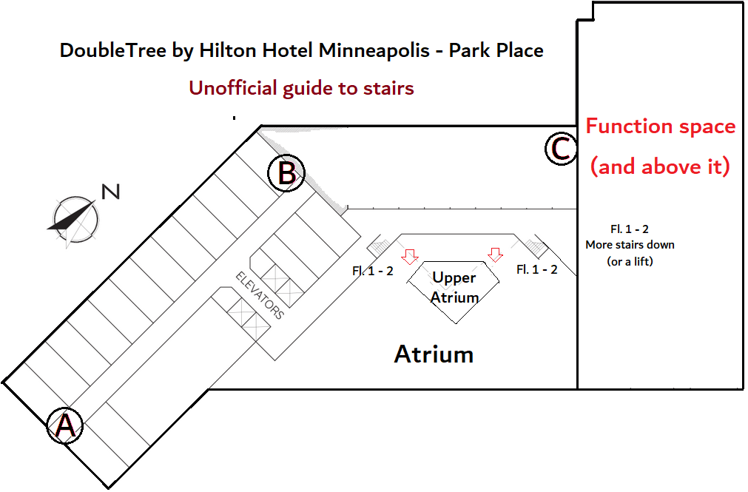
Stairs A: Emergency exit. No access to 1st floor. 2–13 unlocked. Floors 14 + 15 exit-only.
Stairs B: Non-emergency exit. No access to 1st floor. 2–13 unlocked. Floors 14 + 15 exit-only.
Stairs C: Non-emergency exit. Otherwise, access to floors 3 + 4 only (in short part of hotel).
Atrium stairs: Floors 1 and 2 are connected by stairs in the atrium (the big open part of the hotel). Floor 1 is split-level, with the north end being lower. There are stairs and a super slow lift by the restaurant, or you can go around outside from the front door to the door marked "Dover." This year the weather is mostly above freezing and mostly dry for this last option. —Matt Strait

Have an announcement, a news story, a review, a personal item, or anything else for the BBT? Drop it in the Submission Box outside the BBT Office or write to bbt@minicon57.mnstf.org.
====================================================

The Bozo Bus Tribune
Volume 57, Issue 1
Editor – Thorin N. Tatge
© 2024 by the Minnesota Science Fiction Society. Any opinions expressed herein are those of the contributors, not necessarily anyone else's.

