Issue 4 Saturday midnight

Bozo Bus Tribune

T h e O f f i c i a l O r g a n o f M i n i c o n 5 7
“ W e ' r e a l l b o z o s o n t h i s b u s ! ”

Programming reviews
It happened, you watched it, maybe you were on some of it. But you also missed a bunch of it! So here's some notable moments and takeaways.
=--=--=--=--=--=--=--=--=--=--=--=--=--=--=--=--=--=--=--=--=--=--=--=--=--=
“Fanfiction Through the Generations”
This well-attended Saturday morning panel covered the history of fan fiction, with a focus on AO3 (Archive of Our Own). We learned about niche categories (sub-sub-subgenres?) of fan fiction based on other fiction or oddball ideas, like Tony the Tiger/The Grinch and The Snake Fight Portion of Your Thesis Defense. They discussed the practice of refitting works for commercial markets by “filing off the serial numbers,” as with Cassandra Claire or E. L. James. We were also reminded that things like Lancelot's insertion into the King Arthur tales by the French or Dante's self-insertion into his Inferno could be seen as fan fiction, meaning this is a (transformative) tradition that's been around a very long time.
“I haven't read you the dirty fanfic I wrote when I was your age.” —Mother to son
=--=--=--=--=--=--=--=--=--=--=--=--=--=--=--=--=--=--=--=--=--=--=--=--=--=
“Retold Fairy Tales”
Fairy tale junkies were entertained during Friday’s “Retold Fairy Tales” panel. Academic humor and quips flew fast and furious from panelists. Their consensus was that evolving cultures are drawn to fairy tales’ universal themes. But the rise of written and visual storytelling has reshaped oral tales designed for audiences at campfires and igloos.
Is entertainment diminishing these classic tales of survival and ethics? No, but it’s okay if one misses that Disney’s Cinderella is linked to Chinese footbinding. Stories of the past are worth retelling in new ways or perspectives. Humanity’s values, wartime ethics, and gender roles keep evolving. Fairy tales do too. However, casual fans should avoid asking aficionados about hot-button topics like Joseph Campbell and Motif Indexes. Medieval violence may erupt that is influenced by the original Brothers Grimm stories. You’ve been warned.
—Randy Holland
“Shipping Light & Darkness”
“I’d rather punch Nazis than fall in love with them,” and “Are good bastards worth knowing?” are just two of many memorable lines uttered in Friday’s “Shipping Light and Dark” panel. For fanfic newbies like me, “Shipping” is defined as “the act of creating a romantic pairing between two people or characters who are not otherwise romantically linked.” Platonic examples were discussed too. This kind of fanfic often has whimsical motives, and passionate fan bases. Yet this panel pondered heavy questions too. Sure, opposites can attract, and/or make a fascinating fusion of values. But can cruel sociopaths be trusted to never harm again? Is meanness needed to challenge unfair societal norms? How can rules and order not supress personal freedoms? Are consequences enough, and/or redemption realistic for some characters? (Think Darth Vadar, Daenerys Targaryen, Negan, etc.) What evil can a good person justify to be get the ends they want? (Think Scarlet Witch, Severus Snape, Paul Atreides, espionage stories, etc.) This newbie left the panel thinking fanfic shipping was a murky, but worthy, topic.
—Randy Holland
=--=--=--=--=--=--=--=--=--=--=--=--=--=--=--=--=--=--=--=--=--=--=--=--=--=
“Ursula Vernon Q&A”
Author GoH Ursula Vernon on getting stuck writing with ADHD: Write the word “[Gap]” or “[Stuff happens here]”, then finish the book out of sequence.
On distinct character voices: She doesn't use a technique, but if in reading she can't tell two characters apart, she may give one a verbal tic. Often, she writes without knowing quite what she's doing.
Vernon often shows her partner her works: “Kevin, you have to read this and see if it shames my ancestors!” He sometimes has to read in private, or Ursula will read into every sniffle or expression. Once he exclaimed “What the actual ****!?” only to hear footsteps crossing the upper floor, descending the stairs, and approaching: “What scene was that?”

Most interesting item on the Dover's breakfast menu:
Walleye Benedict, with the traditional English muffin replaced with a walleye patty. It's good!
A strange survey
Want to contemplate the nature of existence as through smoked intellectual glass, with a dollop of humor? Look for a becostumed guy with a clipboard called Eric, possibly in the Summer room, and ask to take the Infinity Corporation Survey! (Infinity Corporation is a respected ESP [Existence Service Provider].)

T-shirt price drop
Minicon 56 reprint T-shirts are now only $10!
—Registration desk, one assumes

Saturday reg update
Warm bodies: 508 Total reg: 552
Saturday at the door: 31

Karen Schaffer points out that in addition to Nebula nominations, both Naomi Kritzer and Ursula Vernon have been recently nominated for Hugos. Naomi’s "Better Living Through Algorithms" is a finalist for Best Short Story, "The Year Without Sunshine" is a finalist for Best Novelette, and LIBERTY'S DAUGHTER is a finalist for the Lodestar and nominated for the Minnesota Book Award. Ursula’s Thornhedge (as T. Kingfisher) is nominated for Best Novella.

Lost and found (it's like poetry)
Currently in lost and found: Vassar water bottle, thumbnail-sized wooden beholder magnet, Neil Gaiman's Day of the Dead, glasses found in Science Room.
—Info Desk

Pre-registration offline
Online pre-registration for Minicon 58 is not yet working. You can pay by cash or check here at the reg desk, or in the bar during the Dead Dog Sunday night, or online at the special M57 rate, $5 off, for one week after we get the website working (maybe as early as Sunday of con?)

Missed Denny's memorial?
The showing of Denny Lien's memorial wasn't terribly successful, as it started late due to a previous presentation's technical difficulties and then the sound quality proved unable to fill the room. However, the video, whose audio is reportedly fine with headphones, is on the “David Dyer-Bennet” YouTube channel under the name “Denny Lien Memorial June 2023.”
“Parents in Young Adult Literature”
Kidlit authors like to murder parents. They also like to give kid characters mean and/or absentee parents. These backstories keep readers’ focus on the kid characters. Plus, being parent-free lets young protagonists take risks. Yet Saturday’s “Parents in Young Adult Literature” suggested kidlit is changing.
Sad orphans and/or idiotic adults are tired tropes. The all-writers panel shared modern kidlit stories with realistic families, supportive parents, adults with character arcs, and kids teaming up with adults. None denied these newer stories are trickier to write. Or, that “It’s okay to just kill one (parent), they come in pairs.” But there was optimism that kidlit is evolving to reflect societal changes, newer parenting styles, and ultimately healthier family relationships. And fewer orphanages is a good thing, right? Well done panelists!
—Randy Holland
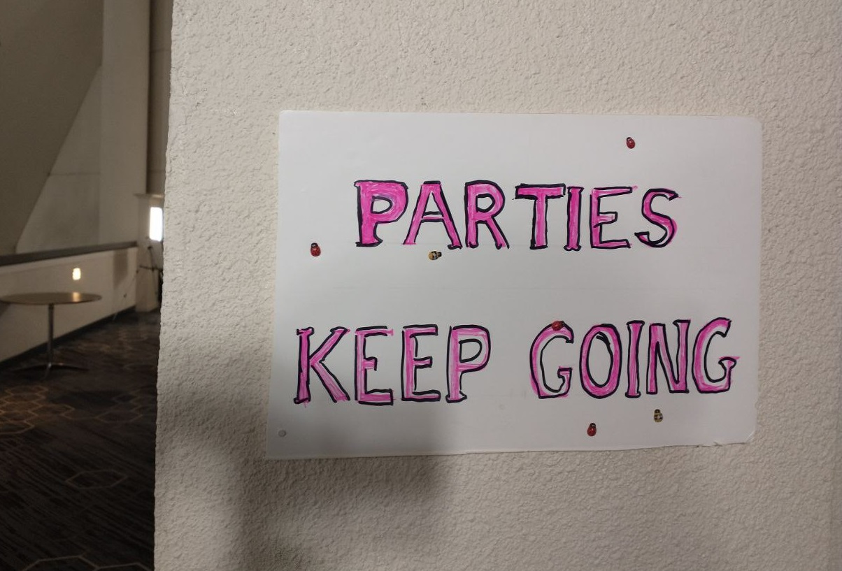

Not had enough, then?
Do you wish Minicon were just a little longer? Continue your convention conversations and munch of the last of the Consuite's food at the Dead Dessicated Dodo party! Hosted by Mn-STF president Sharon E. Kahn and her husband, Richard Tatge.
Where: 4002 Pillsbury Ave in South Minneapolis.
When: Monday, April 1st, 4p.m. - late

There may be one more issue this year! You can still submit, whether by box or by bbt@minicon57.mnstf.org.
====================================================

The Bozo Bus Tribune
Volume 57, Issue 4
Editor – Thorin N. Tatge
Contributor – Randy Holland
© 2024 by the Minnesota Science Fiction Society. Any opinions expressed herein are those of the contributors, not necessarily anyone else's.

