Issue 5 Sunday noon

Bozo Bus Tribune

T h e O f f i c i a l O r g a n o f M i n i c o n 5 7
“ W e ' r e a l l b o z o s o n t h i s b u s ! ”

One last review for the road!
At Saturday morning's “Collection Bias,” panelists wrangled with the challenges faced by librarians and archivists in deciding what to keep in their collections. (Do they keep shelves and shelves of bound academic journals, or decide how far back to subscribe electronically?) Archivist GoH Jeremy Brett pointed out that every archivist has biases that need to be balanced against the needs of their collection. Other hitches, according to Rhiannon Taylor, include “community bias, library locations and community history.” “What is recognized as important is also challenging.”
Magenta Griffith described the “weeding” of collections as a constant process. She informed us that librarians would rather you didn't put your books back on the shelves—not just because they're worried you won't put them in the right place, but because they want a count of which books have been consulted, which will inform their future collection management decisions. “Before computers, librarians would put marks in books for how many times it was checked out. Now computers help with that.”
Brett pointed out that in different eras, different materials, such as old horror fiction, can transition from being popular to being used for research. It was pointed out that science fiction, too, has fashions—Phillip K. Dick was weird and obscure until the Blade Runner movie made him popularly known.
On racism, misogyny, etc. in older books, there was some debate whether librarians should move them out of general collections in order to keep “the wrong person from finding the wrong book.” Griffith, after a notion by Jo Walton: “There's a lot of books the suck fairy has visited.”
Brett pointed out that every story out there was read and enjoyed by somebody. And he admitted that his Science Fiction & Fantasy Research Collection at Cushing Memorial Library “collects buttloads of fanfic; I believe we have the largest collection of print slash in the world, which is kind of embarrassing.”
A SHOUT OUT
Big thank you to the con suite staff for the little things in life – fruit – beverage – hot water – protein – wonderful service!

Missing an inhaler?
One was found in the upper atrium and is currently in the Lost & Found, along with the items listed in the previous issue.

Chicago traingoers beware!
The Amtrak to Chicago that should have left St. Paul this morning, did not! It hit a car (killing the driver) and is listed as being at least 8 hours late. I have no idea what effect this will have on other trains today and tomorrow.
—Rich Price, Badge 101

Such witchery!
The plan anonymously espoused in Issue 3 came to fruition; Karen Schaffer did in fact bid $100 on the Andre Norton Witch World maps with the intention of donating them to the Cushing Archive!

Ursula on “Writing for Adults”
“The failure mode of whimsy is twee.”

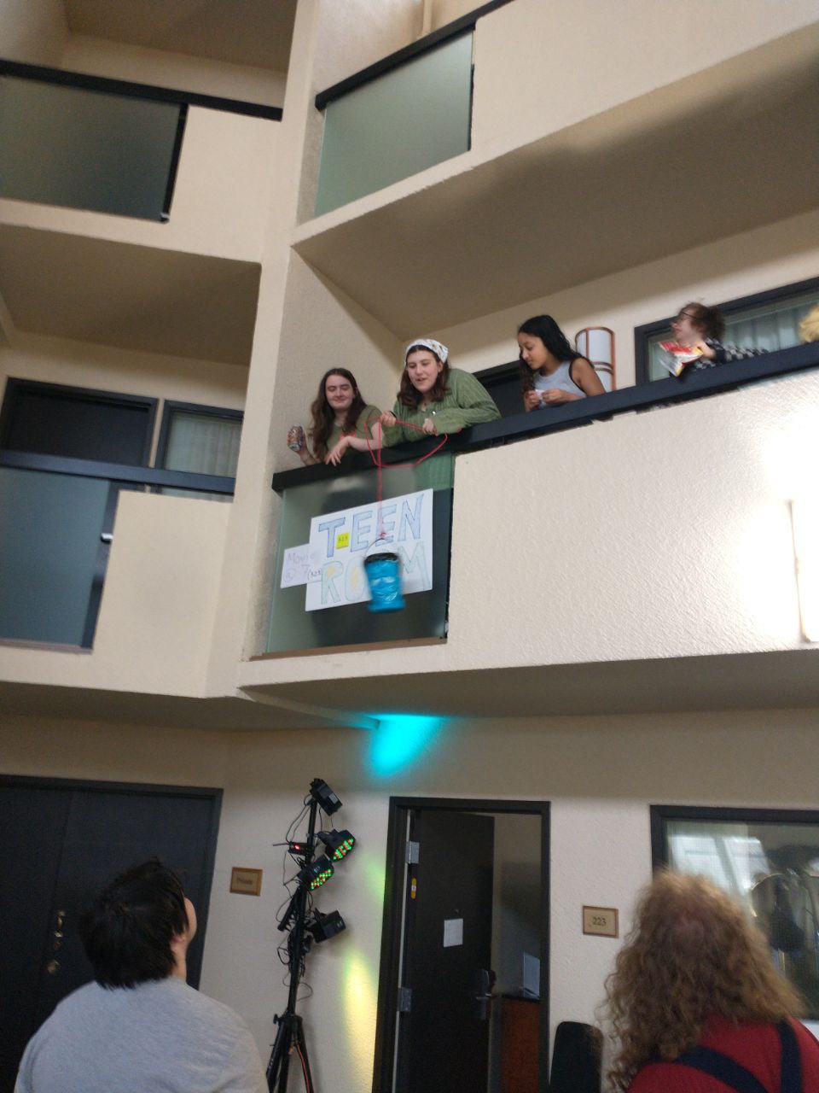
Put in a cheesy slice of your time
There will be pizza for volunteers who participate in clean-up right after Closing Ceremonies and work continuously until 6p.m.! We'll break for pizza in the Consuite, finish up after, then on to the Dead Dog party.

6a.m. Body Count:
5

EXTRA, EXTRA, Medallion Hunt
<=LAST PRIME BEFORE LEGAL=>

/=\=/=\=/=\=/=\=/=\=/=\=/=\=/=\=/=\/=\=/=\=/=\=/=\=/=\=/=\=/=\=/=\=/
The following medallions have been found in these locations:
1. Found between 2 vertical “legs” of one of the wooden tables in the hotel’s main lobby
3. Found on freebie table under a knitted flower vase, on Saturday, soon after placement
5. Found on the back of the top of the programming area water cooler table, Saturday. Intended Clue: Mickey Mouse, a flammable gas, “Ugly bags of mostly __________”
15. Carried by LillySong Watson
20. Carried by Nora Strait
A. This Medallion is dead as the Con Bar is not open until after tear down on Sunday, J = sorry! This Medallion was taped to the bottom of the mixers table in the Con Bar
C. Carried by Michael Hagerman
D. Found taped to the bottom of the black fire extinguisher cabinet near Reg. Intended clue: If things get hot, you’ll want to run right up to me. I may not be of any help, myself but you’ll still want to run here.
F. The back of the large, black flower pot near the free-will donations table
G. Was taped to the back of the towel shelves/rack in the pool area
H. Was taped to the upper part of the wall light/sconce near the main elevator bay on 2, between wall light/sconce and wall.
J. On one of the lowest, angled/inclined parts of the wall sculpture above the table outside Green Room.
π. Carried by Jim Porter
/=\=/=\=/=\=/=\=/=\=/=\=/=\=/=\=/=\/=\=/=\=/=\=/=\=/=\=/=\=/=\=/=\=/
C L U E S : R O U N D 2
2. I swing back and forth, but only occasionally, from my perspective. I’m on a dark-colored background. You can only really see me when I’m swinging or when my swing reaches its maximum, but you likely won’t be at a good angle to see me then. I’m near something wet. This is at least the third year that this spot has been used.
4. If you’re tired near Reg and want a place to sit, you will likely sit on top of me…. Well, on top of some piece of furniture, to which I’m clinging.

6. Take a chance on finding me, seek the place where I will be. “Get out of Jail”, “Community Chest”, if you want to you win, try your best. Chop the Tree, Swing the pendulum, search the room. Check along the edges. The prior clue was mistyped, should’ve read: Take a chance, roll the dice, try to find me. I’ll be playing hide & seek, awaiting you. Sorry for my misspelling.
7. So many will pass right by me at all times of day. When the sun is out, you might not stay. This spot has also been reused at least 2 or 3 times. Hint: “This spot” can be taken with us back to the RadiShTree, (even if not these exact coordinates on the planet).
8. (8 – 10 are not on floors 1 or 2.) I was here in the past but no one found me. My number and floor were different. I’m hanging out hoping my tape holds. If not, it’s the floor for me. I hope someone comes up here and finds me. I’m facing away from you, in fact, I’m facing a wall.
9. As a fellow attendee just told me in the elevator, “You [I] have the view.” Please come up here and find me. Note the black pins on the leaderboard are for those above floor 2.
10. You’d pass me if you want to go up or down. Just a push is all you need to pass right over me. I’m above deck 2. Not a clue: Happy Easter to those celebrating.
B. Mirror, mirror on the wall, I am near drinks for all.
E. My area can be loud. If my immediate space stays “quiet” I’ll be proud. If I’m disturbed, you will be too. I’d hope the cause of such wouldn’t be you… or any of us.
I. Similar to J’s former location which was found near, but outside of Green Room. However, not exactly right nearby that location. Same floor though
K. Publishing is your friend, here… Maybe something for Bozos, by Bozos? Gravity is your friend too! Don’t worry, you’ll find your way, you’re on a roll!
L. People have been doing puzzles above me without even knowing it for most of con?

See you next year! Be dodos seldom and sparingly.
====================================================

The Bozo Bus Tribune
Volume 57, Issue 5
Editor – Thorin N. Tatge
Contributor – Scott Lohman
Game Keeper - J
© 2024 by the Minnesota Science Fiction Society. Any opinions expressed herein are those of the contributors, not necessarily anyone else's.

